Academic Programs:

1. **PGDM Analytics - 22nd batch**

**(2 Years full time course approved by AICTE co-branded by IBM & certification by Harvard Business School’s HBX)**

**TAG LINE: An unique opportunity to study from the best academicians and the best corporate house of the world**

**Why PGDM Analytics @ ASM’s IIBR**

* Students will have an opportunity to study from the leaders in analytics, and mentored by the experts in this field.
* Analytics is deemed to be the most lucrative and in demand as a preferred career, and IBM are the leaders in this field.
* The course curriculum has been designed by IBM and will be partially delivered by IBM Subject Experts
* ASM is also the first B school to partner with Harvard Business Schools’ initiative HBX for the CORe program, and students of PGDM will undergo this elite program.
* On successful completion the students get a certificate from HBX and will be enrolled as alumnus of Harvard Business School.
* Harvard Business School’s Live Case Study taught by the expert faculty members of Harvard Business School.
* Opportunities to get short term certificate courses at very affordable cost from some of the best international universities
* Student Exchange Programs
* Regular curriculum delivered by expert faculty members from india and abroad
* The only institute to be promoted by chamber of commerce.

**Admission Procedure & Eligibility (General admission page)**

**Apply now (Form)**

**Download brochure**

**Download syllabus**

**PGDM BA- 23rd batch**

**(2Years full time course approved by AICTE with certification from Harvard business School’s HBX & IBM)**

**TAG LINE: An unique opportunity to study from the best academicians and the best corporate house of the world**

**Why PGDM at ASM’s IIBR**

**Tie-up & Alliances for this course**

1. **ASM being the first B school in india to tie-up with Harvard Business Schools HBX ,Students of PGDM have the privilege of enrolling for the HBX CORe program an initiative by Harvard Business School , and on successful completion earn the credential of readiness from HBX and Harvard Business School**
2. **Opportunity to study from the best in the world, faculty members from Harvard Business School teaching the Harvard Business School’s Live case study**
3. **Additional opportunity to study certification course in analytics designed by IBM and partially delivered by IBM Subject Matter Experts.**
4. **Students have a truly global learning experience by getting to complete an international internship from USA/Mexico/Europe.**
5. **The only institute to be promoted by chamber of commerce.**

**Admission Procedure & Eligibility (General admission page)**

**Apply now (Form)**

**Download brochure**

**Download syllabus**

**MBA - from City U, Seattle**

**ASM’s IIBR offers the unique opportunity to transfer credits of the first year PGDM to City U, Seattle , USA for the MBA program.**

**Why MBA from City U, Seattle, USA through ASM’s IIBR**

* **Syllabus accredited by City U, Seattle, USA one of the top ranked universities in the world**
* **Easy transfer of credits to the second year of MBA**
* **No requirement for GRE /GMAT**
* **Very Affordable and cost effective**
* **The MBA program and the university City U are accredited**
* **Students have the additional advantage of having completed the HBX CORe, readiness program offered as an initiative of Harvard Business School**
* **Students have the opportunity to work in USA as per the US government regulations after completion of the Course at City U.**
* **Study in One of the key cities of USA that houses prime brands like Microsoft, Amazon etc.**

**Admission Procedure & Eligibility (General admission page)**

**Apply now (Form)**

**Download brochure**

**Download syllabus**

**IIBR : Infrastructure**

**IIBR Campus has unique advantages of being located at a prime location, right on the main highway, surrounded by markets, hospitals, shopping mall, entertainment facilities, industries, corporate houses etc. The campus location makes student life very convenient and comfortable and also very conducive to get connected with the industries in and around**

* Campus Photo

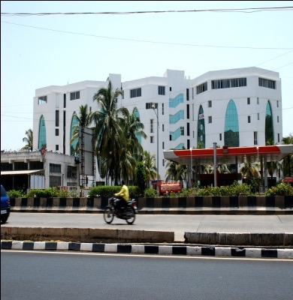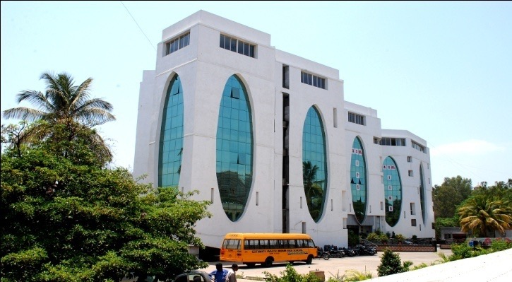

* Class Rooms:

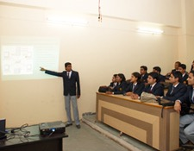 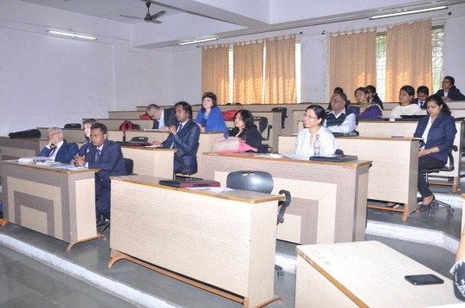

* Computer Lab

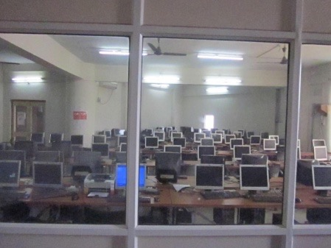

* Library

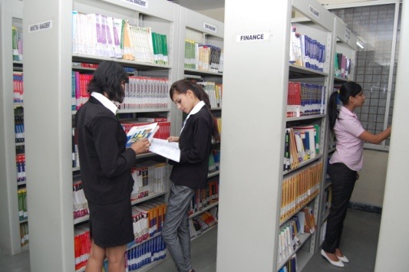 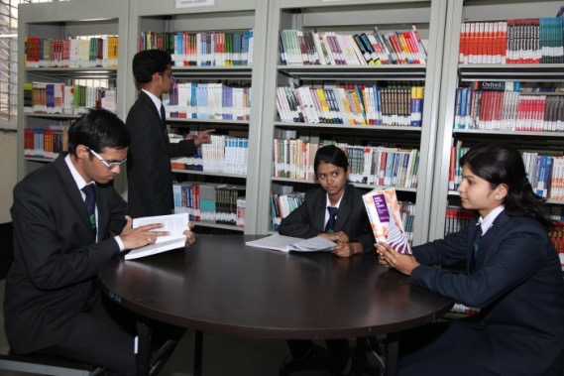

* Canteen

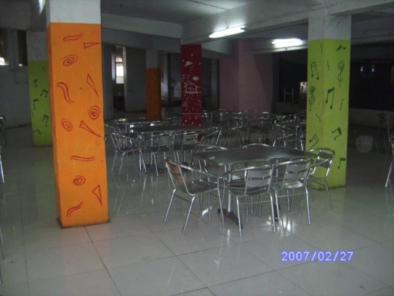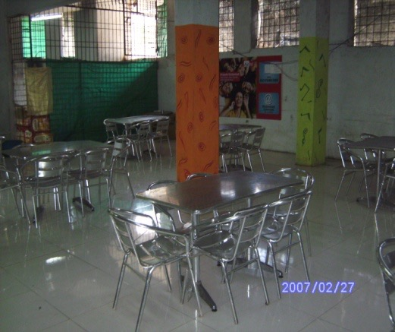

* Sports& Gym

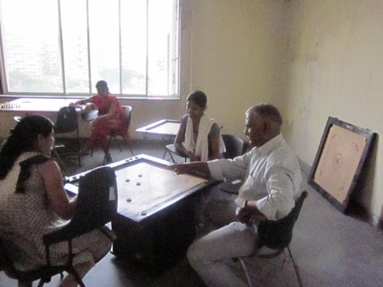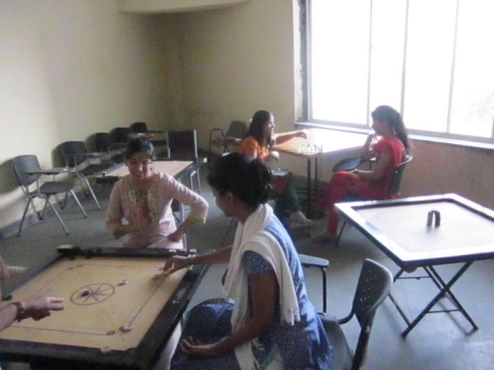

* Boys & Girls Hostel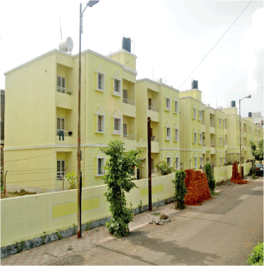

**Faculty**

IIBR is known for its academic credentials and innovative outlook, with support from the chamber of commerce, faculty from universities abroad, IBM, Harvard Business School. The institute, being autonomous, nurtures a culture of flexibility and creativity to help promote high-quality education, training, research and consultancy in management.

Faculty Members include experts from industry, academia, govt. bodies. Expert from the industry act as part time faculty members, global exposure through regularly visiting common faculties, holistic development of students through various educational social and cultural activities, contemporary teaching methods.

**Foreign Faculty/Visiting Faculty:**

ASM'S does not restrict its students to national boundaries but groom them to be global global professionals. ASM provides global exposure to students when various experts from around the globe visit the institute every year to share global management inputs with the students. Thus, ASM has been very successful in creating niche competent individuals for the global competitive corporate set up.



 